**How to run the Blood Bank Donor Management System Django Python**

1. Download the zip file

2. Extract the file, copy bbdms folder, and paste it on the desktop

3. Open MySQL Create a database bbdmspythondb then import the SQL File available in the SQL File Folder (For MySQL we used the [XAMPP](https://phpgurukul.com/how-to-install-xampp/)server)

4. Open PyCharm and click on the terminal

5. Navigate the project folder using the cd command

cd project_path

**For ex:**cd C:\Users\ANUJ\OneDrive\Desktop\bbdms\

6. Now Navigate to the bloodbanksystem folder

cd bloodbanksystem

7. Run the Project using the following command

python manage.py runserver

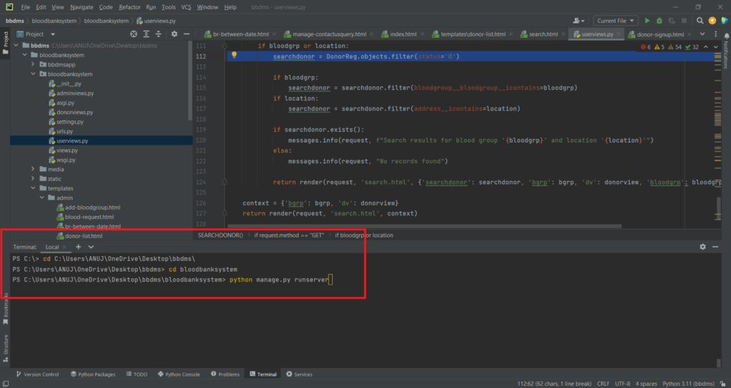

Now click the URL http://127.0.0.1:8000 and the Project will run

**Login Details**

**\*\*\*\*\*\*\*\*\*\*\*\*\*admin\*\*\*\*\*\*\*\*\*\*\*\***

**Username:**admin

**Password:** Test@123

**\*\*\*\*\*\*\*\*\*\*\*\*\*Donor\*\*\*\*\*\*\*\*\*\*\*\***

**Username:**test123

**Password:** Test@123 OR Register new donor

**For More Detail visit:**

<https://phpgurukul.com/python-projects-free-download/>